Sierra Leone

## Freedom House political status

The data set shows the Freedom House political scores and status of the country each year.

## # A tibble: 19 x 5  
## country iso3c date mean status   
## <chr> <chr> <dbl> <dbl> <chr>   
## 1 Sierra Leone SLE 1996 4.5 Partly Free  
## 2 Sierra Leone SLE 1998 4 Partly Free  
## 3 Sierra Leone SLE 2000 4.5 Partly Free  
## 4 Sierra Leone SLE 2002 4 Partly Free  
## 5 Sierra Leone SLE 2003 3.5 Partly Free  
## 6 Sierra Leone SLE 2004 3.5 Partly Free  
## 7 Sierra Leone SLE 2005 3.5 Partly Free  
## 8 Sierra Leone SLE 2006 3.5 Partly Free  
## 9 Sierra Leone SLE 2007 3 Partly Free  
## 10 Sierra Leone SLE 2008 3 Partly Free  
## 11 Sierra Leone SLE 2009 3 Partly Free  
## 12 Sierra Leone SLE 2010 3 Partly Free  
## 13 Sierra Leone SLE 2011 3 Partly Free  
## 14 Sierra Leone SLE 2012 2.5 Free   
## 15 Sierra Leone SLE 2013 3 Partly Free  
## 16 Sierra Leone SLE 2014 3 Partly Free  
## 17 Sierra Leone SLE 2015 3 Partly Free  
## 18 Sierra Leone SLE 2016 3 Partly Free  
## 19 Sierra Leone SLE 2017 3 Partly Free

## Freedom House classification of political change

The data set shows the GDP growth and the ecomic growth classification of the country each year.

## # A tibble: 19 x 4  
## country iso3c date politicalChangeFH  
## <chr> <chr> <dbl> <chr>   
## 1 Sierra Leone SLE 1996 no change   
## 2 Sierra Leone SLE 1998 democratization   
## 3 Sierra Leone SLE 2000 autocratization   
## 4 Sierra Leone SLE 2002 democratization   
## 5 Sierra Leone SLE 2003 democratization   
## 6 Sierra Leone SLE 2004 no change   
## 7 Sierra Leone SLE 2005 no change   
## 8 Sierra Leone SLE 2006 no change   
## 9 Sierra Leone SLE 2007 democratization   
## 10 Sierra Leone SLE 2008 no change   
## 11 Sierra Leone SLE 2009 no change   
## 12 Sierra Leone SLE 2010 no change   
## 13 Sierra Leone SLE 2011 no change   
## 14 Sierra Leone SLE 2012 democratization   
## 15 Sierra Leone SLE 2013 autocratization   
## 16 Sierra Leone SLE 2014 no change   
## 17 Sierra Leone SLE 2015 no change   
## 18 Sierra Leone SLE 2016 no change   
## 19 Sierra Leone SLE 2017 no change

## Freedom House score trend

The plot shows the Freedom House scores trend of the country.

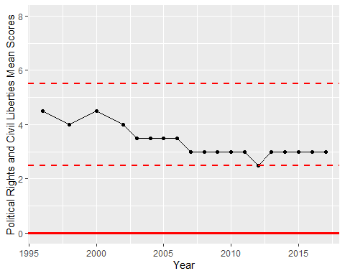

Freedom House Score Trend